IBM Rational Quality Manager

**Test Data Management using Data Pool feature**

**By**

**V Niranjan**

**Vniranjan72@outlook.com**

Table of Contents

Test Data Management using Data Pool feature 3

Creating Test Data in IBM Rational Quality Manager 5

Import Test Data in to IBM Rational Quality Manager 6

Associate the Test Data in to IBM Rational Quality Manager Test Script 9

Execute the IBM Rational Quality Manager Test Script with Test Data 14

Viewing Execution Results in IBM Rational Quality Manager 18

Summary 20

**Refrence Links…………………………………………………………………………………………………………………………………..**

# Test Data Management using Data Pool feature

In my previous article about IBM Rational Quality Manager @ <http://www.softwaretestinghelp.com/ibm-rational-quality-manager-rq-tutorial/> we saw about how the tool can be used for day to day test management activities including manual testing. In this article I will show how the manual testing feature can be extended to use Test Data feature using data pools. Test data is about using multiple values which will act as input to the test script during its execution.

For this article I have used **IBM Rational Quality Manager version 6.0.2** which is part of IBM Rational CLM (Collaborative Life Cycle Management)

Let’s take for example the test case which is created called **Test Case for Purchase of Music CD Online**

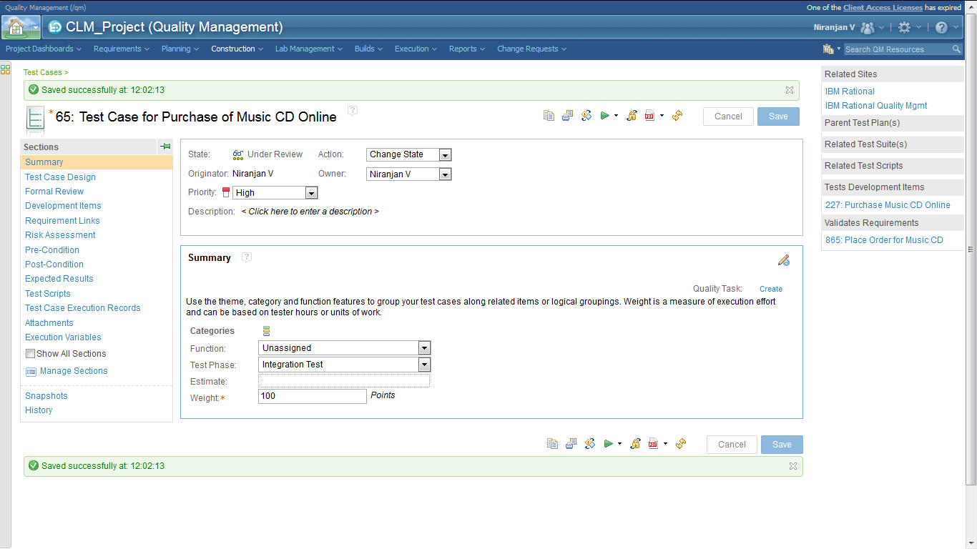

For the above Test Case let’s have a look at the test script created. Click on the **Test Scripts section** on the left to view the test scripts. Click on it to open the same.

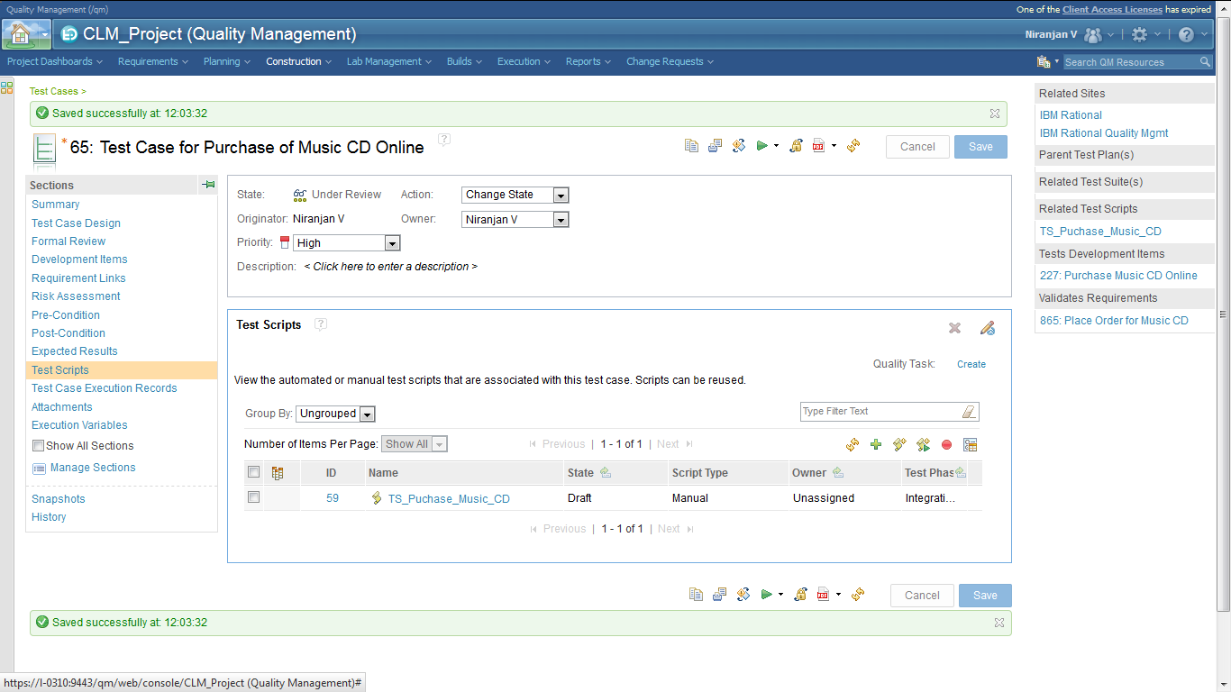

Consider the manual test script as shown here.

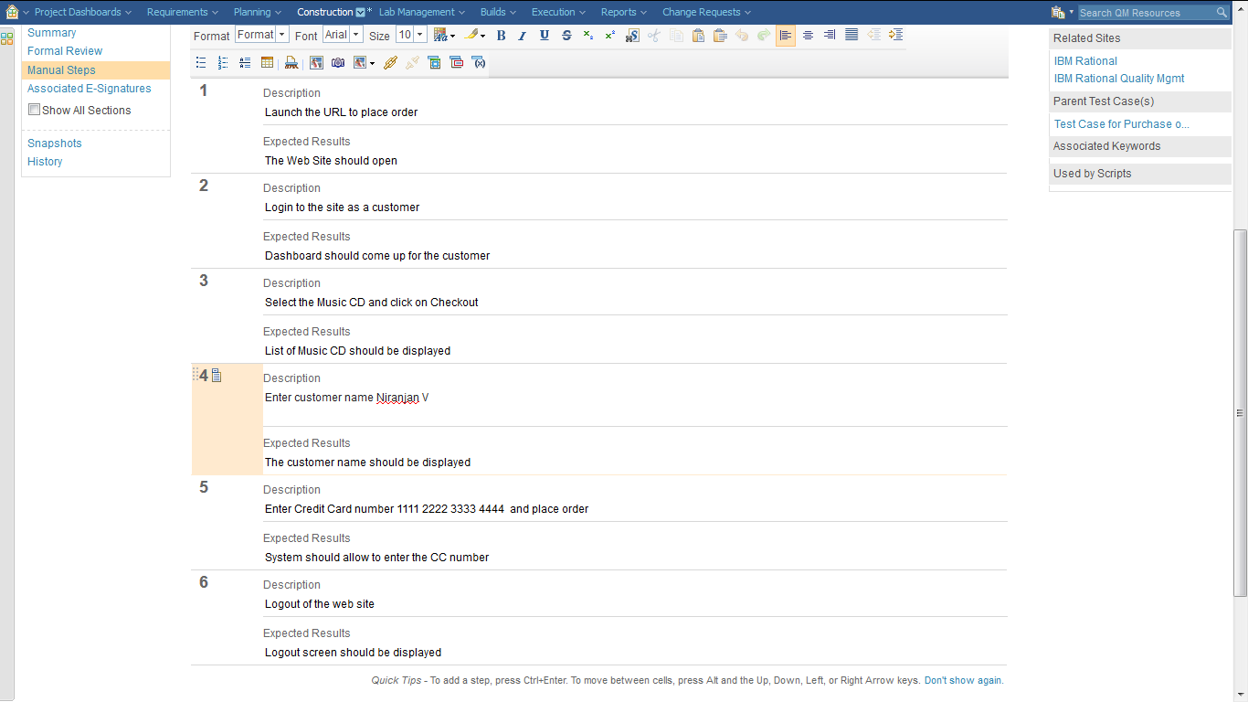

Take a look at step 4 and 5. The Name and Credit card number is hardcoded. If we need to run the above script for multiple customer names and credit card numbers then we would need to use test data management using data pools which is described in this article.

# Creating Test Data in IBM Rational Quality Manager

In order to create Test Data we will need to create a CSV file containing multiple Customer names and Credit card numbers as shown below. The CSV file contains 2 columns.

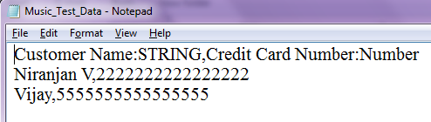

So in the CSV file we have created 2 fields to hold Customer Name and Credit Card Number as String and Number type.

We will now need to import the Test Data created above in to IBM Rational Quality Manager and link it to the manual script which is shown above. Since there are 2 entries in the CSV file for test data when the manual test script will run it will run as 2 iterations.

# Import Test Data in to IBM Rational Quality Manager

To import the above test data in RQM go to Construction🡪Create🡪 Test Data

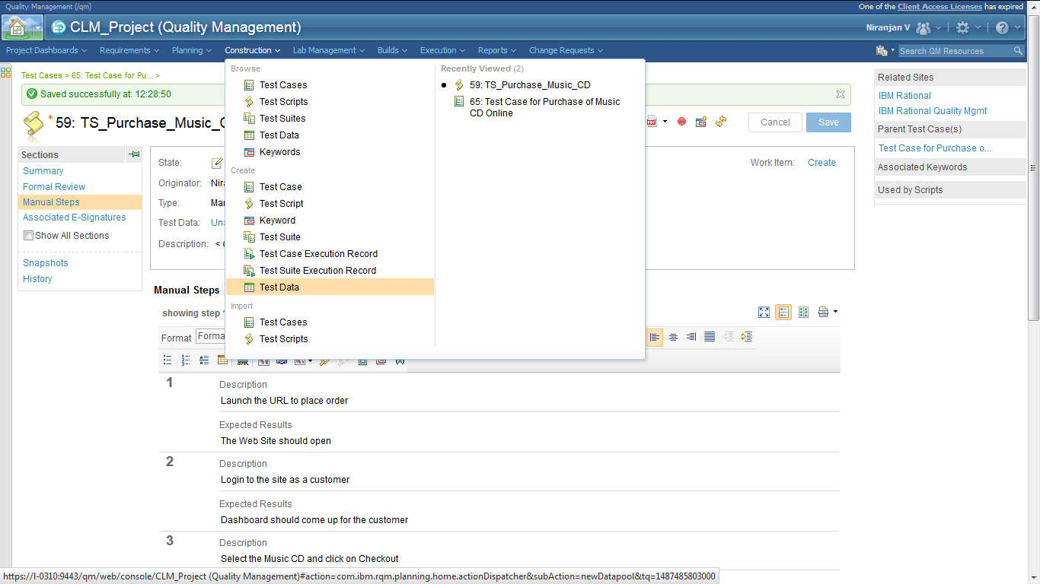

Enter a name and under **Data File** section browse and select the CSV file created. Save the changes.

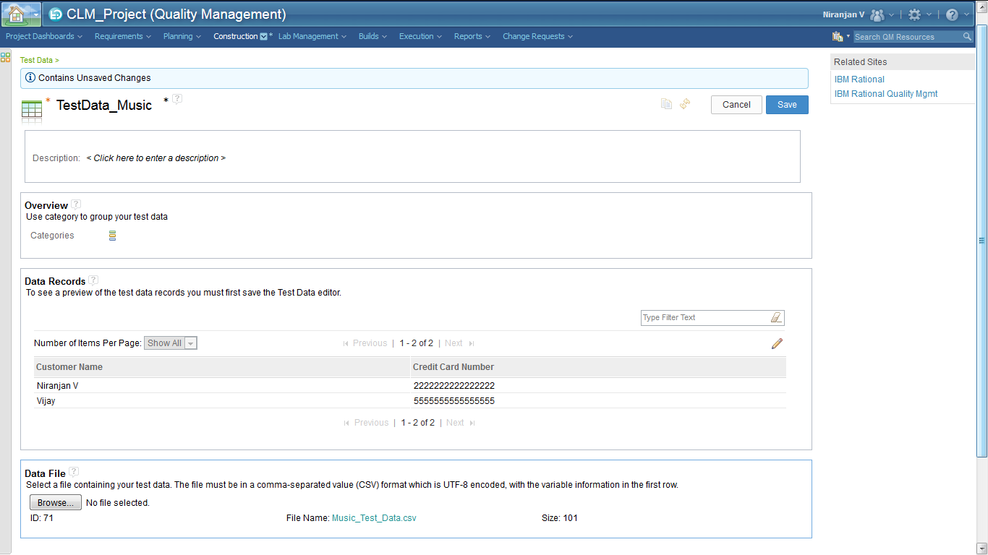

The **Data Records** section shows the content of the CSV file after it is imported. As per the CSV file it correctly shows the values of 2 records.

# Associate the Test Data in to IBM Rational Quality Manager Test Script

To associate the test data in to IBM Rational Quality Manager test script open the manual test script and click on the Edit button for Test Data as shown

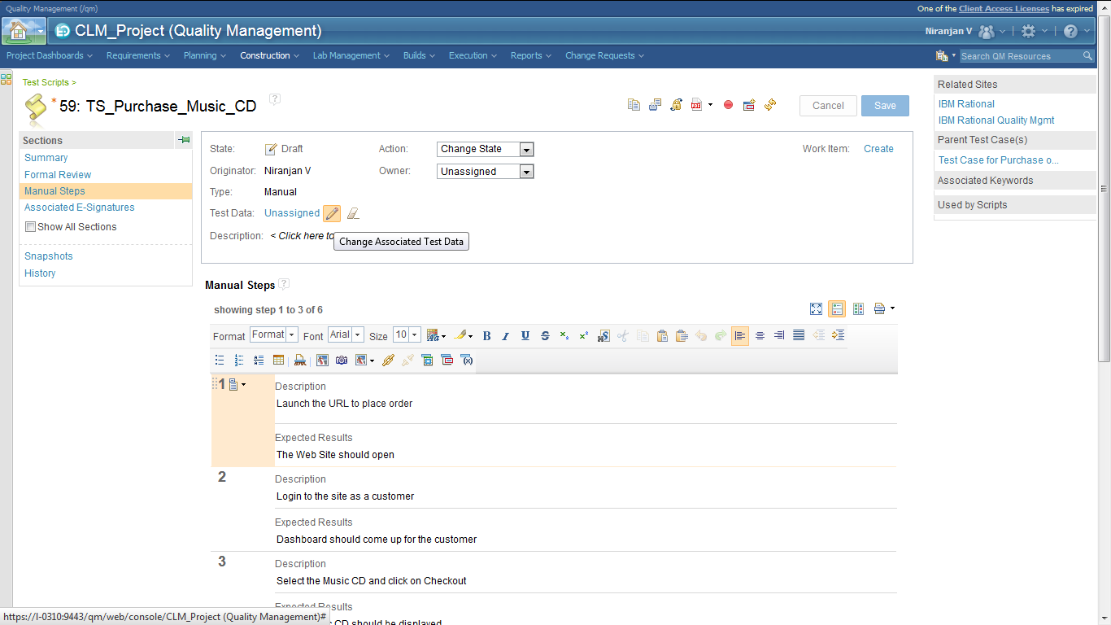

The Test Data imported is shown. Select the same and click OK and **Save** the changes.

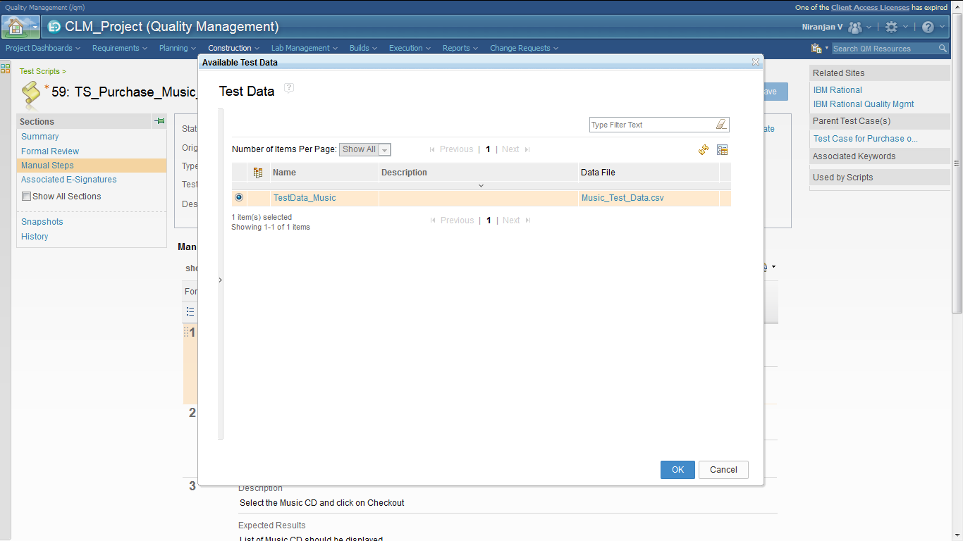

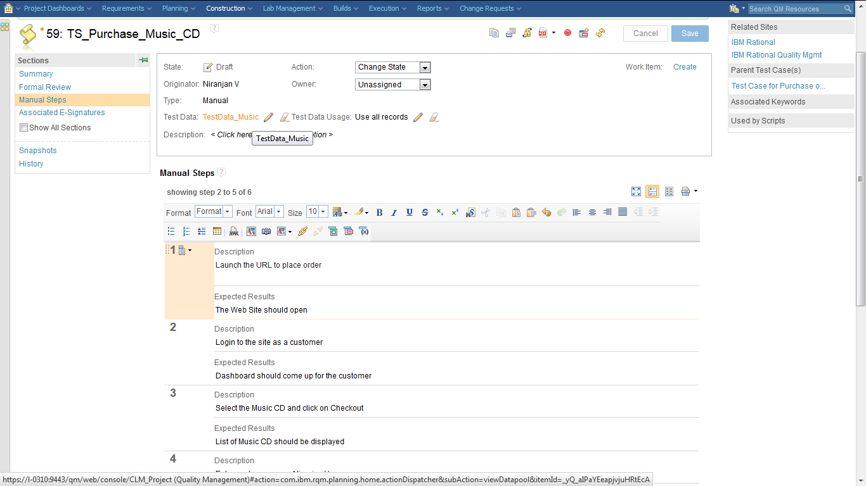

Now since in steps 4 we have the Customer Name hard coded we will replace it with the Customer Name column from the CSV file. In step 5 we have Credit Card number hard coded we will replace it with Credit Card number from the CSV file.

In step4 highlight the Name (Niranjan V) and select the option ‘Insert Test Data Column’

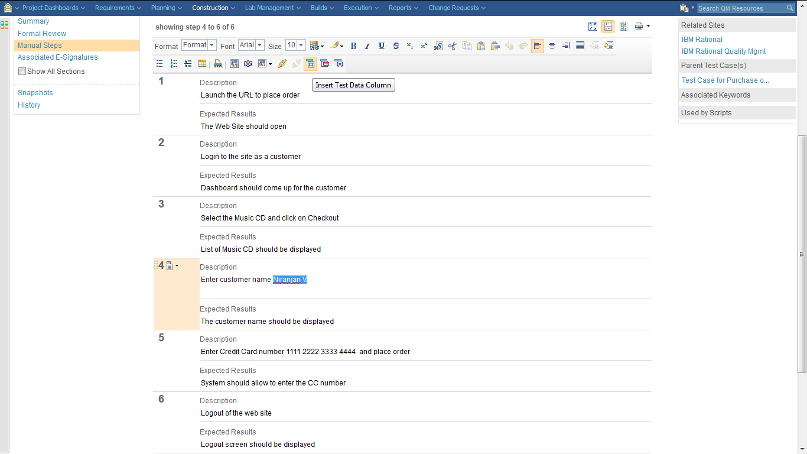

In the resulting screen select the column **Customer Name** and click on **Insert Test Data Column**

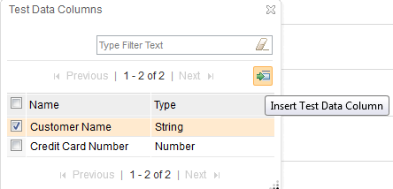

The Name (Niranjan V) is now replaced with the column name from test data which is Customer Name

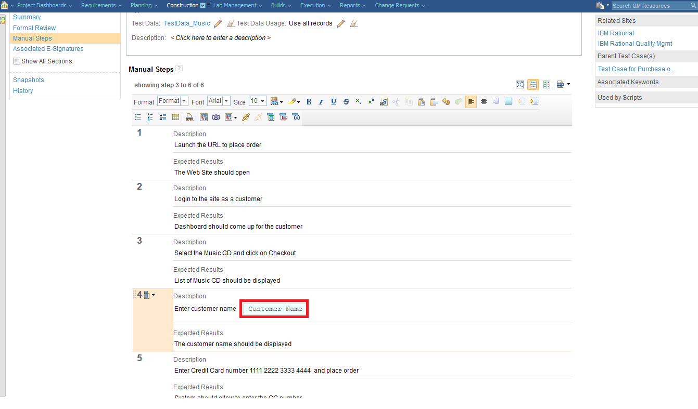

Similarly high light the Credit Card number and Insert Test Data Column for the value highlighted.

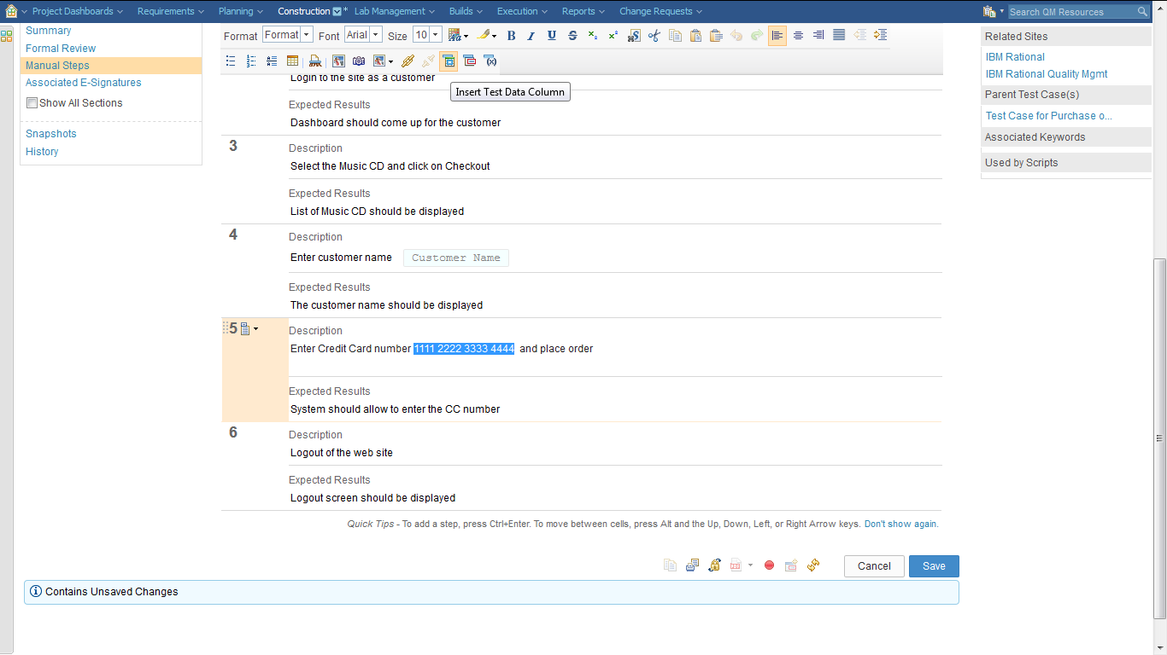

In the resulting screen select the column **‘Credit Card Number’** and click on **Insert Test Data Column**

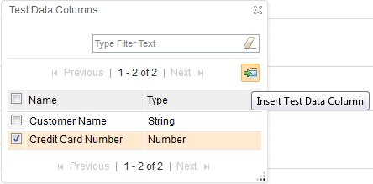

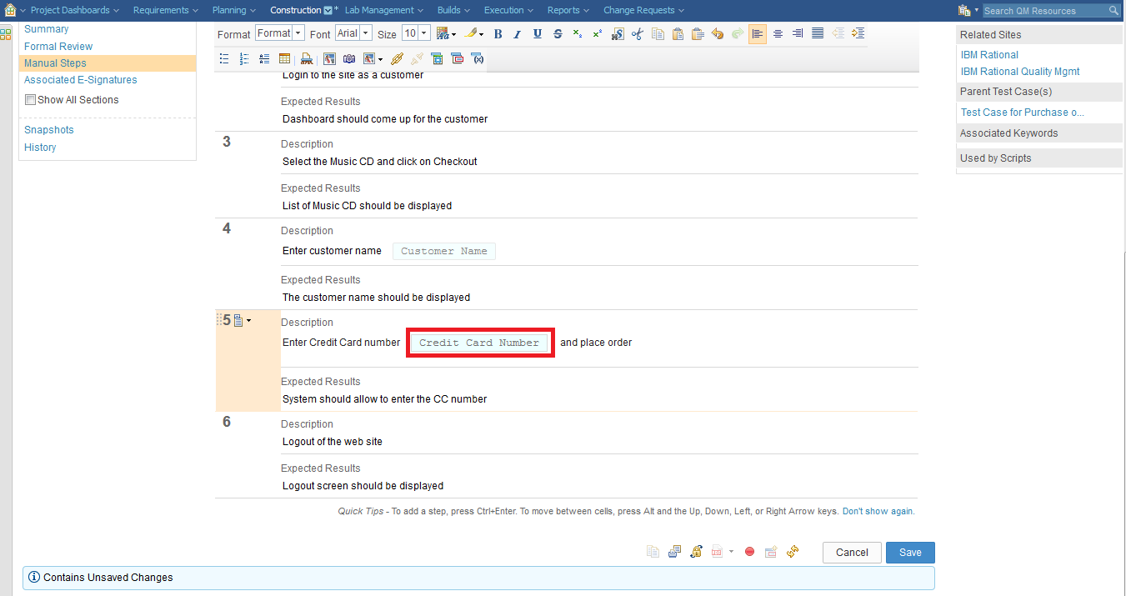

The credit card value is now replaced with the column name from test data which is Credit Card Number.

Remember to **Save** the changes. The final screen now looks as shown below.

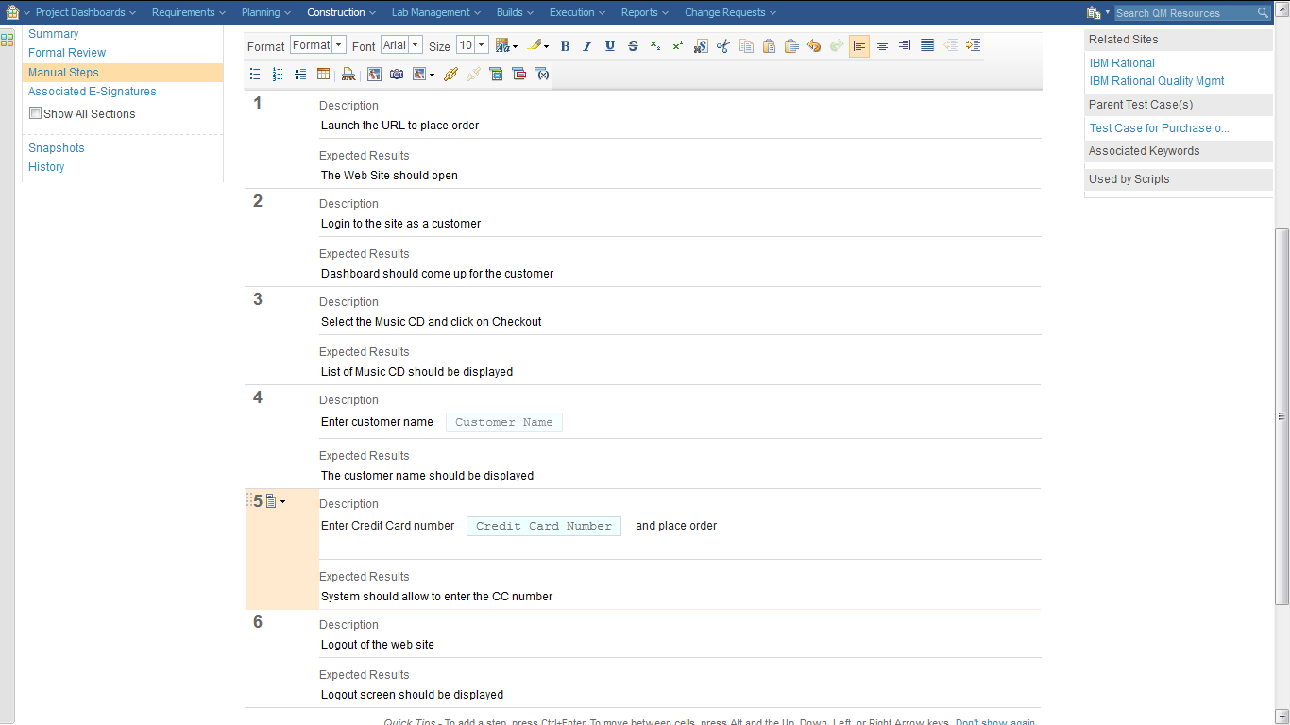

# Execute the IBM Rational Quality Manager Test Script with Test Data

1. To execute the Manual script with test data go to Construction🡪Browse🡪 Test Cases
2. Go to the Test Scripts section

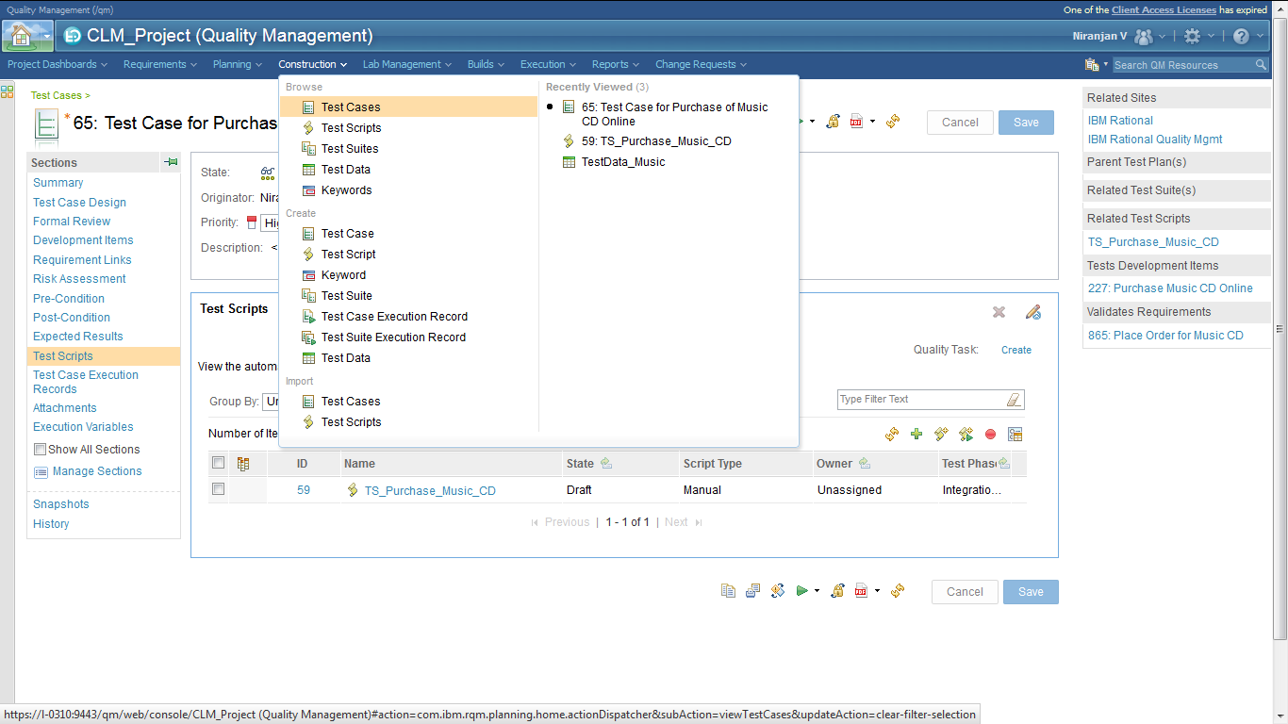

1. Select the Test Script and click on **Run** as shown

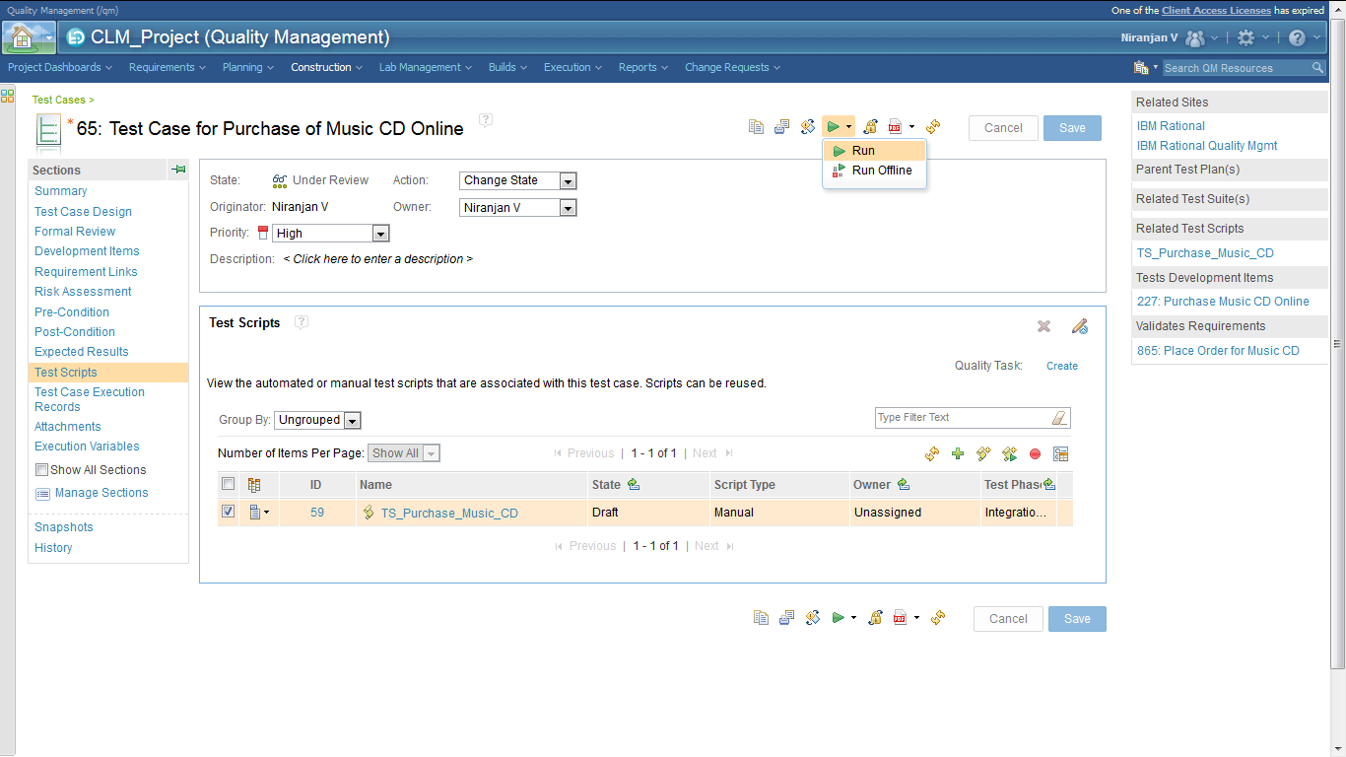

1. In the Run Test Case screen which comes up ensure the Test Script is selected which has the test data associated with it and click on **Finish** to begin the execution.
2. The execution screen now shows the first data for Customer Name and Credit Card number. The screen also shows it is executing for **Iteration 1**

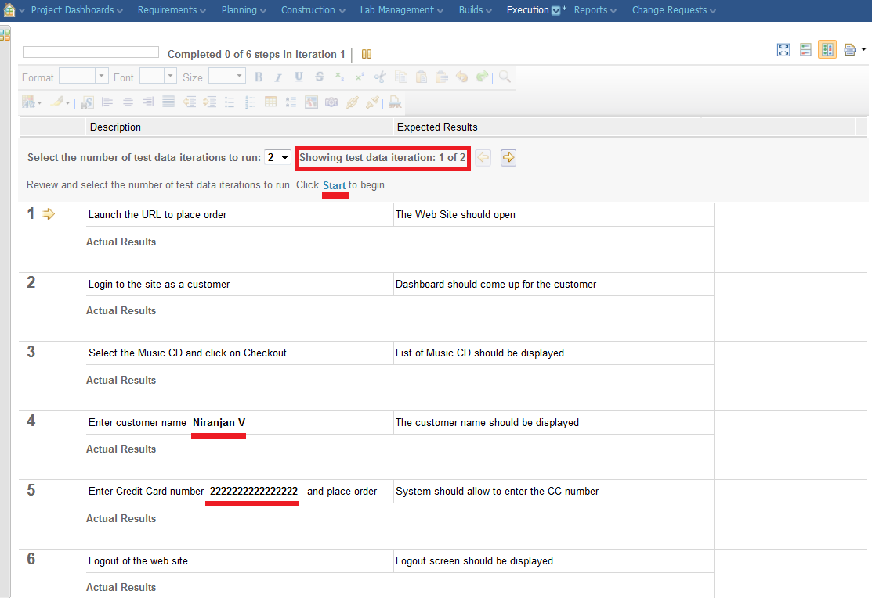

1. Click on **Start** link to begin the execution

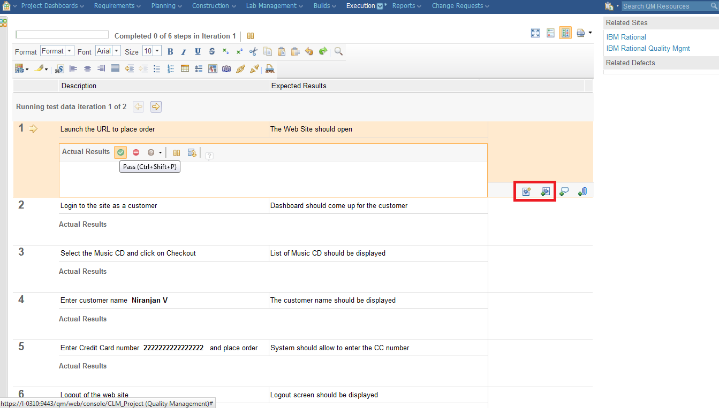

1. Click on Pass for every step. You can also record the Actual Results out of the execution. Remember you can also associate the step to an existing defect or create a new defect.
2. Once all the steps have finished its execution you can see that the screen now moves to **Iteration 2** and has loaded the second data.

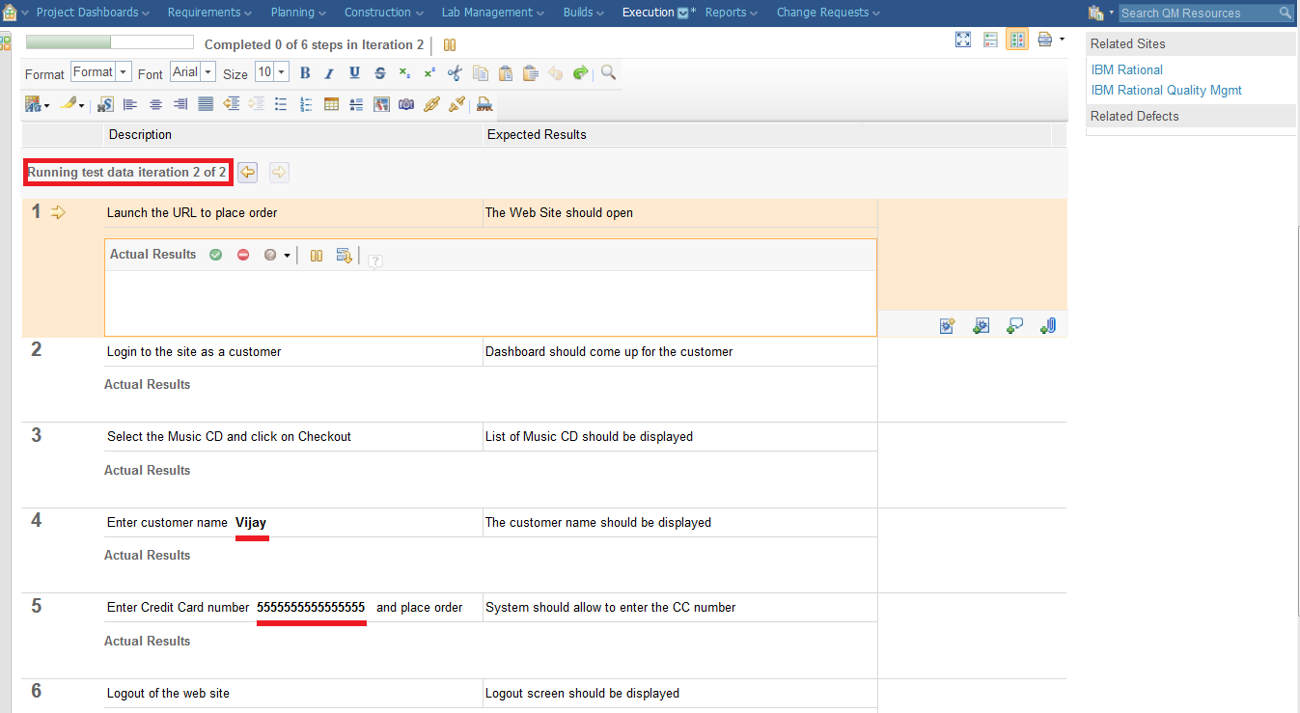

1. Complete the execution. Click on Pass for every step and select Show Result.

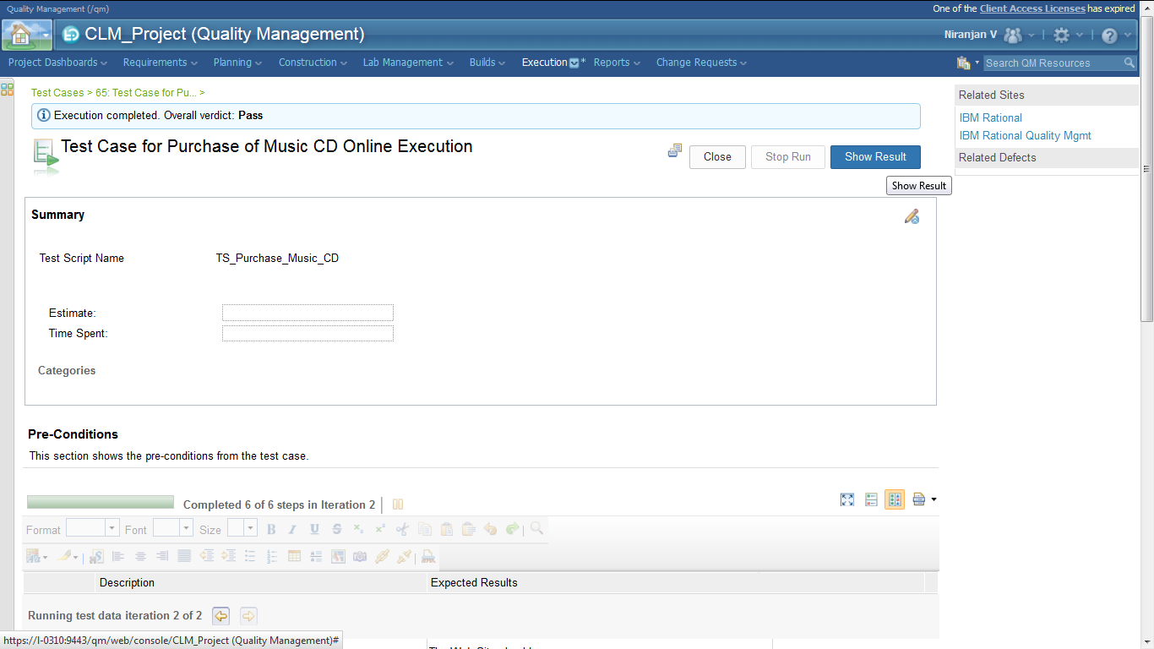

1. The Summary report will show you results for Iteration 1 and 2.

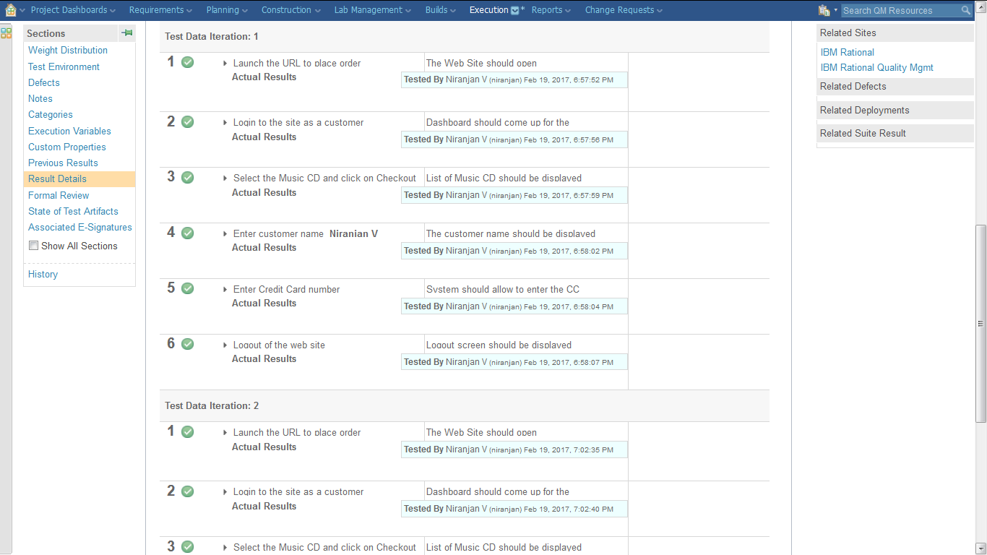

# Viewing Execution Results in IBM Rational Quality Manager

To view the execution results at a later time go to **Execution 🡪 Test Case Results**

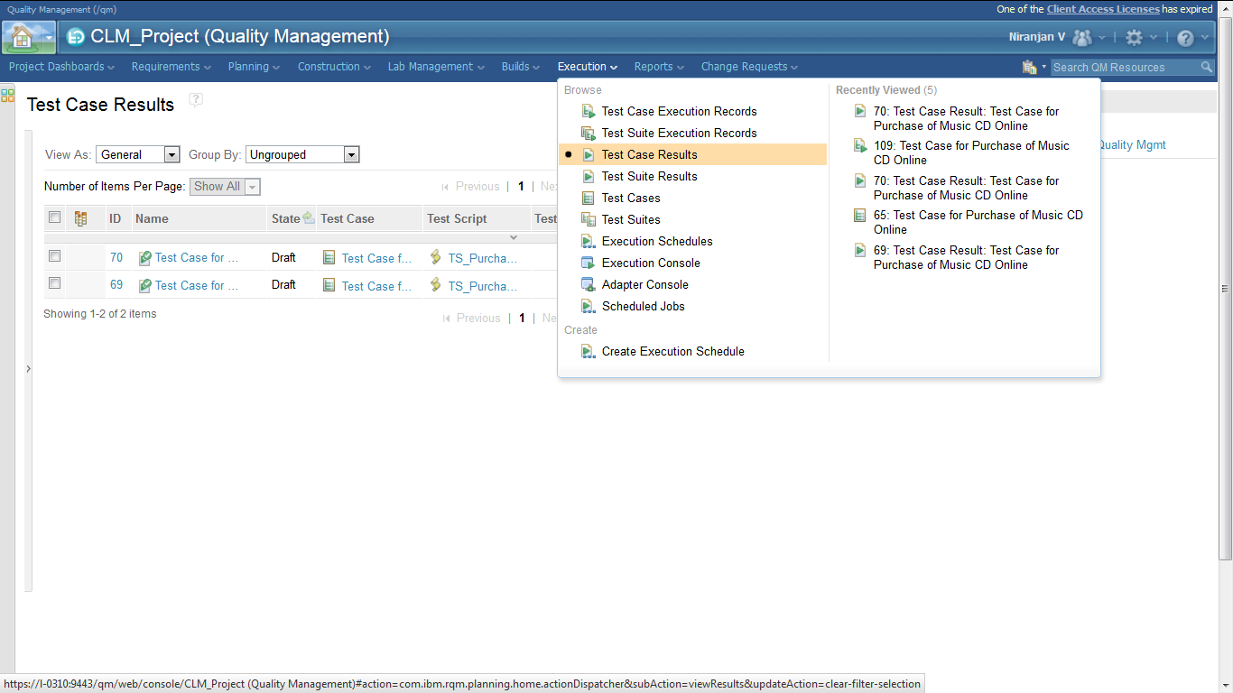

Click on the first result which is the latest and you can view the execution results for the Test Script

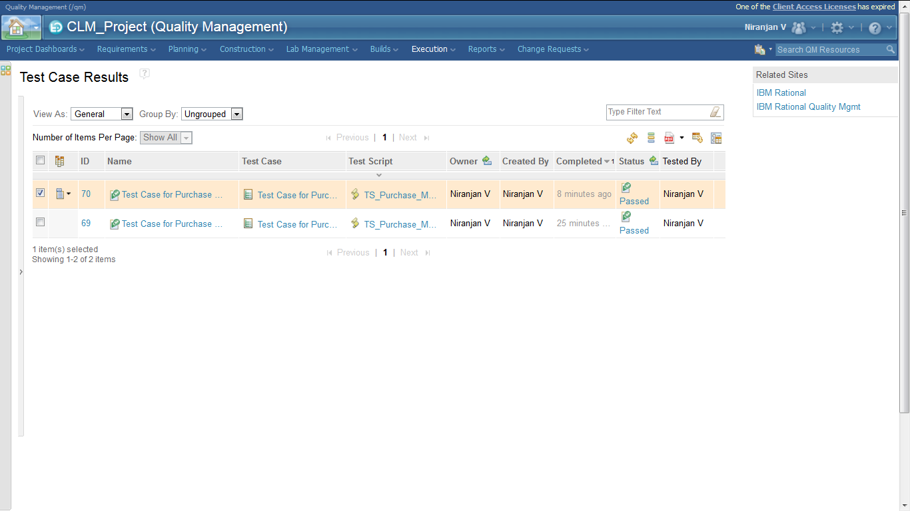

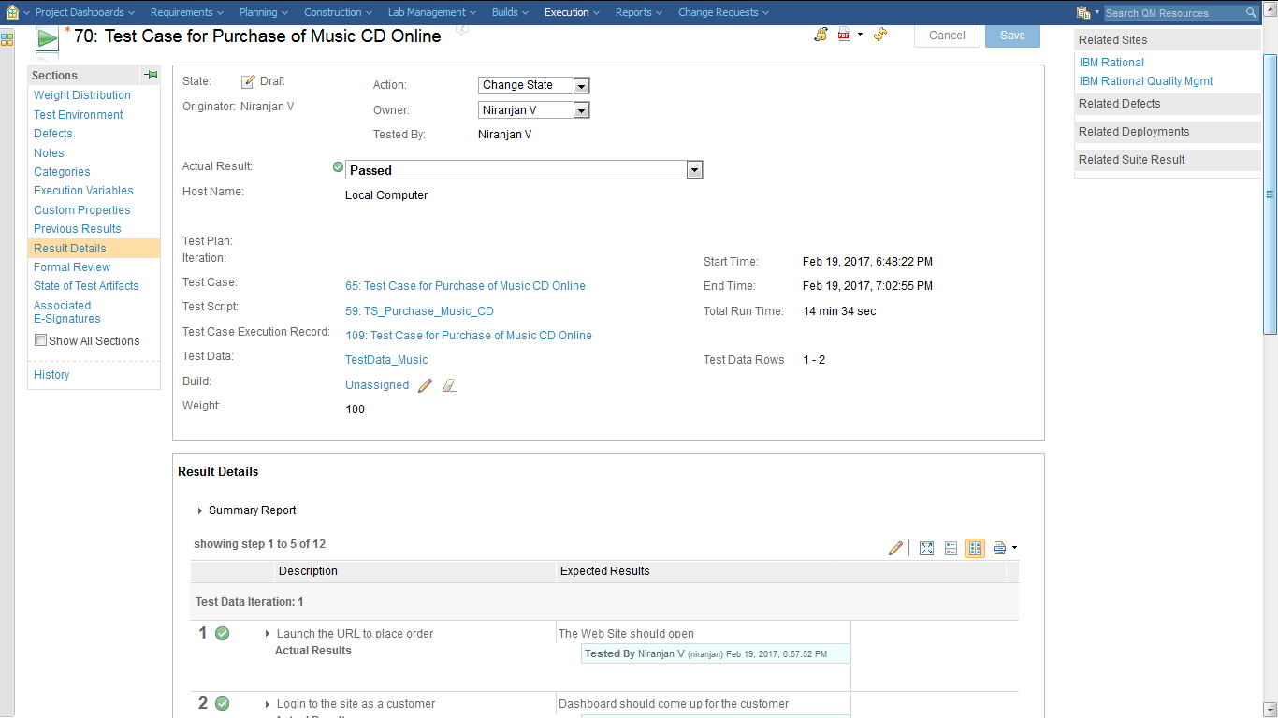

The above screen shows execution results for both iterations.

# Summary

Hope now it is clear to all of you as to why data pools are used from the point of view of using multiple values as input to one single script.

So in summary we have seen the following

* How test script can actually be reused to use test data containing multiple values. You need not create multiple test scripts for every value.
* To create test data using CSV files and import test data in to RQM
* Associate test data values within the test script
* Execute test script containing the test data
* Viewing execution results for all the values in the test data

Refrences:

https://jazz.net/forum/questions/204373/rqm-testing-testing-a-single-or-multiple-test-data-scenario-with-test-data-or-execution-variables